

OWEN GRADUATE SCHOOL OF MANAGEMENT

MANAGEMENT 6438

COMMERCIAL REAL ESTATE DEVELOPMENT

FINAL PROJECT
Grassmere Business Park: Which Path Forward?

Instructors: Lewis Agnew & Dirk Melton Module III
Spring 2026

SUMMARY

The Final Project in Commercial Real Estate Development is a real-time case study occurring in the first Quarter of 2026 in Nashville, Tennessee. The Final Project is intended to identify the highest and best use for an underperforming real estate asset, in this case a 1980’s-vintage suburban commercial office building that is mostly vacant.

The format of the case study mimics a consulting arrangement, whereby the groups have been engaged to advise an investment partnership as to the best path forward in consideration of their present circumstances, with the goal of protecting, and perhaps enhancing, investor equity.

The groups will analyze the partnership’s situation and recommend a path forward by evaluating three scenarios: 1) selling the property as-is, 2) re-leasing the buildings to one or more commercial office tenants, and 3) demolishing the buildings and replacing them with another use.

THE LOCATION

648 Grassmere Park Drive is a commercial office complex located in Grassmere Business Park in the South Nashville office submarket. Grassmere Business Park is an office and light industrial park developed primarily in the 1980’s, featuring a dozen existing buildings on about 100 total acres. The development is bordered by a CSX Railroad line to the north, Elysian Fields Drive to the South, the Nashville Zoo at Grassmere to the east, and Trousdale Drive to the west.

Vehicular access to Grassmere Business Park is exclusively from Trousdale Drive, a two-lane roadway with access to Interstates 65 and 24 via Harding Place, which is approximately one mile away. Adjacent development patterns include industrial, manufacturing and distribution uses to the north, a residential neighborhood to the south, the aforementioned Nashville Zoo to the east, and low-rise office buildings fronting Trousdale Drive and the CSX Radnor Yard to the west.

The underlying zoning classification for Grassmere Business Park is Industrial Warehouse District, or IWD, which permits most commercial office and light industrial uses by-right. Most of the buildings in the park contain traditional commercial office space and some warehouse/flex uses. To construct improvements other than office and industrial uses on the property, such as multifamily residential, a rezoning would be required that permits the proposed alternative use.

THE ASSET

Completed in 1985, 648 Grassmere Park Drive was built as an operations center for BellSouth Corp. (now AT&T) and features two building structures: a 162,550 rentable square foot (SF), 3-story office building (the “Main Building”) and a single-story, 61,649 SF support building (the “Annex”) which share a climate-controlled connecting corridor. Other property improvements include an exterior courtyard located between the buildings, and surface parking lots totaling 1,205 spaces (a ratio of 5.4 spaces per 1,000 SF). The main building features traditional office space, while the annex features a datacenter and redundant power from large diesel-powered generators on site.

An affiliate of MarketStreet Enterprises purchased 648 Grassmere Park Drive in 2015 via the entity MarketStreet Grassmere, LP. The purchase price was $25,938,000 ($116/SF) and at the time the buildings were fully occupied by Asurion, LLC, a company that provides insurance for smartphones, tablets, consumer electronics, appliances, satellite receivers and jewelry. Based in Nashville, Asurion is one of the largest employers in Middle Tennessee, with a local workforce of about 3,600. At the time of the acquisition, Asurion had 6 years remaining on its 10-year lease.

Due to the company’s rapid growth at the time, in 2016 Asurion initiated a process to build or expand its headquarters office presence to around 500,000 SF. Several development companies proposed sites for the headquarters requirement. As the existing landlord, MarketStreet was asked by Asurion to propose expanding the existing 224,000 SF facility at Grassmere by roughly doubling its size through a major renovation and expansion representing a $40 Million new investment.

THE LEASE

Ultimately, Asurion entered into a lease with Highwood Properties for a new 570,000 SF build-to-suit office building in the North Gulch submarket, moving into the so-called “Gulch Hub” in 2022. Asurion’s lease for both Grassmere buildings expired in March 2021, however the company’s plans required a datacenter operation outside of the new headquarters facility, so Asurion entered into a lease with MarketStreet whereby the company would continue to occupy the annex building. Currently, Asurion occupies the annex only, and the lease for that building expires in March 2027.

The main building at 648 Grassmere Park Drive has been vacant since 2022, notwithstanding MarketStreet’s efforts through its leasing broker, Cushman & Wakefield, to replace Asurion’s tenancy. This situation is mainly attributable to the lack of demand for office space in the wake of the COVID-19 pandemic, especially for so-called “commodity” suburban office product suitable for call centers, a job type for which return-to-office statistics have not been encouraging. Additionally, as a complex constructed for a single user, the main building’s layout cannot be easily subdivided to accommodate multiple tenants, which could facilitate a faster lease-up.

THE LOAN

The income for the current Asurion lease for the annex, while representing 27.50% of the leasable area of the property, is not adequate to cover the carrying costs for the property. Those costs include debt service for the existing loan on the property as well as operating expenses in the form of real estate taxes, property insurance and maintenance for the building and grounds. As a non-stabilized asset with low occupancy, the property is not eligible for conventional bank financing, so the current loan is with a private lender utilizing an interest-only, non-amortizing loan.

This loan matures in December 2029, while the existing Asurion lease expires earlier, in March 2027. If the main building can be leased, the resulting income would likely cover carry costs for the property and open up a refinancing opportunity. If the main building cannot be leased by the time the Asurion lease expires, there will be no income for carry costs, requiring capital calls to the partnership. Asurion has indicated that the company does not intend to renew when the annex lease expires. As a result, MarketStreet wants to evaluate the options available to the partnership such that a strategy can be devised in preparation for the property becoming 100% vacant.

THE SITUATION

Clearly, the pending lease expiration and debt maturity poses a dilemma for the partnership that enjoyed reliable cash flows from the property for many years leading up to Asurion’s departure. At the time of the initial acquisition, a long-term, full-building lease with a large tenant was considered a “safe bet”, making it an attractive prospect for both long-term ownership and in the investment sales market upon disposition. So long as the tenant was in place, the partnership was able to service the debt, amortizing principal along the way, and also make regular distributions.

Ten years later, the future of the property is uncertain. Entering 2026, the market for properties such as 648 Grassmere Park Drive has slowed considerably, evidenced by a lack of leasing activity by end users and poor investment sales prospects for non-stabilized assets. If tenant demand does not return, and there is no opportunity to exit at a reasonable price, it is possible that the buildings are functionally obsolete and no longer the highest and best use for the property. On the other hand, redevelopment entails a completely different risk profile than was contemplated by the partnership upon acquisition and would require significant additional equity capital to execute.

THE SCENARIOS

MarketStreet is interested in at least three unique scenarios for the partnership, as follows:

Scenario 1: Sell

Under this scenario the partnership decides to exit the investment now, assuming an insufficient appetite for deploying more capital into the asset by way of leasing costs to re-tenant the buildings, or else redevelop the property. This scenario contemplates marketing the building as-is, with the Asurion annex lease in place. Evaluating this scenario will require an understanding of the current investment sales market and researching the range of potential sales prices, to understand whether sales proceeds will be adequate to retire the current debt on the property. If it is, then the partnership will receive a distribution from sale. If it is not, the partners will be required to contribute their pro-rata share of any shortfall in sales proceeds to dispose of the asset.

Scenario 2: Re-lease

Under this scenario the partnership continues marketing the property for lease and makes certain assumptions about the terms of the new lease(s) and the length of time required to execute on this strategy while approaching the pending debt maturity. This scenario would require significant capital investment into the asset in the form of tenant improvements and leasing commissions, which while necessary to fill the buildings will also result in a larger cost basis for the partnership (which likely cannot be financed). Evaluating this scenario will require an understanding of the commercial office leasing market, the prospects for refinancing the asset once stabilized, and the likely disposition price for stabilized commercial office buildings in the investment sales market.

Scenario 3: Re-develop

Under this scenario the partnership determines that the existing buildings are no longer the highest and best use for the property and seeks to redevelop the parcel for another product type. Executing on this scenario entails is the most opportunistic and capital-intensive strategy, requiring demolition of the existing improvements and vertical construction of another income-producing use that will possess better leasing and investment sales prospects going forward. Evaluating this scenario will require an understanding of the types of alternative uses and the financing and investment prospects of said uses for development, operations and disposition. Any proposal must consider whether the alternative uses are entitled by-right or would require rezoning. Proposed uses that are not entitled by right are encouraged, however the groups should acknowledge in their evaluation the additional steps (and risks) associated with executing on a rezoning strategy.

THE ASSIGNMENT

At a minimum, each group is to evaluate the three scenarios provided and submit a memorandum to the MarketStreet partnership with their conclusions and recommended going-forward strategy. Additional creative strategies, in addition to those provided, are encouraged, but are not specifically required in order to complete the assignment.

The pages that follow contain a sample format reference for the Final Project deliverable, as a guide. It is not necessary to rigidly follow the sample format, rather it is provided for guidance as to the various quantitative and quantitative considerations for completing the assignment.

Ultimately, the groups should not feel compelled to produce a deliverable based on a prescriptive format, rather they should produce and present the work product they feel is required to convey and explain their recommendations for the investment strategy in completing the assignment.

The following are some guidelines for a successful project. Some of these guidelines may not apply to all projects. Similarly, do not necessarily limit your discussion to the topics outlined below. Simply, use these as a guideline to an effective exploration of the development decision at hand.

Project Site & Situation Analysis

  - Recap situation and decision at hand

  - What are key considerations and decisions to be made?

  - Site Analysis
    - Description of site, including size, zoning, configuration, encumbrances
    - Identify neighboring parcels and their relation/fit with the property

- Market Research & Supply/Demand Analysis (discuss these factors from the standpoint of their impact on your property)

  - Macroeconomic conditions – National economy
~ skip this part; assume your audience knows this; proceed to (b) ~

  - Microeconomic conditions – Define the submarket
    - Submarket characteristics
      - Current status
        - New construction pipeline = supply
        - Occupancy rates, rental rates, sales prices, inventory = demand
      - Global submarket considerations
        - Market characteristics (employers, local amenities, etc)
        - Comparison with other markets
        - Substitution between markets
      - Market outlook
        - Future competition
        - Barriers to entry
        - Short/long term expectation

  - Competitive Analysis (this section is mandatory for inclusion) – profile several of the project’s primary competitors. Analyze the following traits of the competitors, in relation to the subject property. Based on this comparison, evaluate the property’s competitive position
    - Location
    - Physical attributes
    - Pricing
    - Vacancy
    - Ownership

Competitive comparison of the properties to each other

  - Property specific issues & considerations
    - Tenant profile

    - Capital condition
    - Development constraints
    - Other…

Economic Modeling

  - All projects shall include a proforma economic model for the suggested alternative
    - Income
      - Leasing/sales assumptions
      - Ongoing market leasing/sales assumptions (if not merchant-build)
    - Expenses
      - Expenses based on market
      - Inflation assumptions

  - Include financing assumptions – using financing guidance provided or a variation thereof
    - LTV
    - Rate
    - Financing costs
    - Type of financing & terms

  - Tax implications – disregard Federal taxes, for the purposes of this analysis

  - Returns analysis
    - IRR Analysis – complete capital stack, investor preferred return, developer promote and waterfall (if any), return of investment and return on investment
    - Sensitivity Analysis – show various returns based on fluctuating the most important assumptions in your model (you must determine which these are, based on your project)
    - Valuation – at your cost of capital (you pick this), what is the value of the property?
    - Assumption discussion – evaluate which are the important assumptions in the project that must be monitored

- Evaluation of Alternatives – project dependent

  - Use your Project Advisor to guide you through this area

- Recommendations and Conclusions – project dependent

  - Risk Analysis – Include discussion of significant risks or project and suggestions for managing these
  - Recommendations and conclusions

EXHIBITS

- Aerial map
- Property photos
- Site survey
- Floor plans
- Property summary
- Operating summary
- Loan summary
- Zoning summary

A: AERIAL MAP
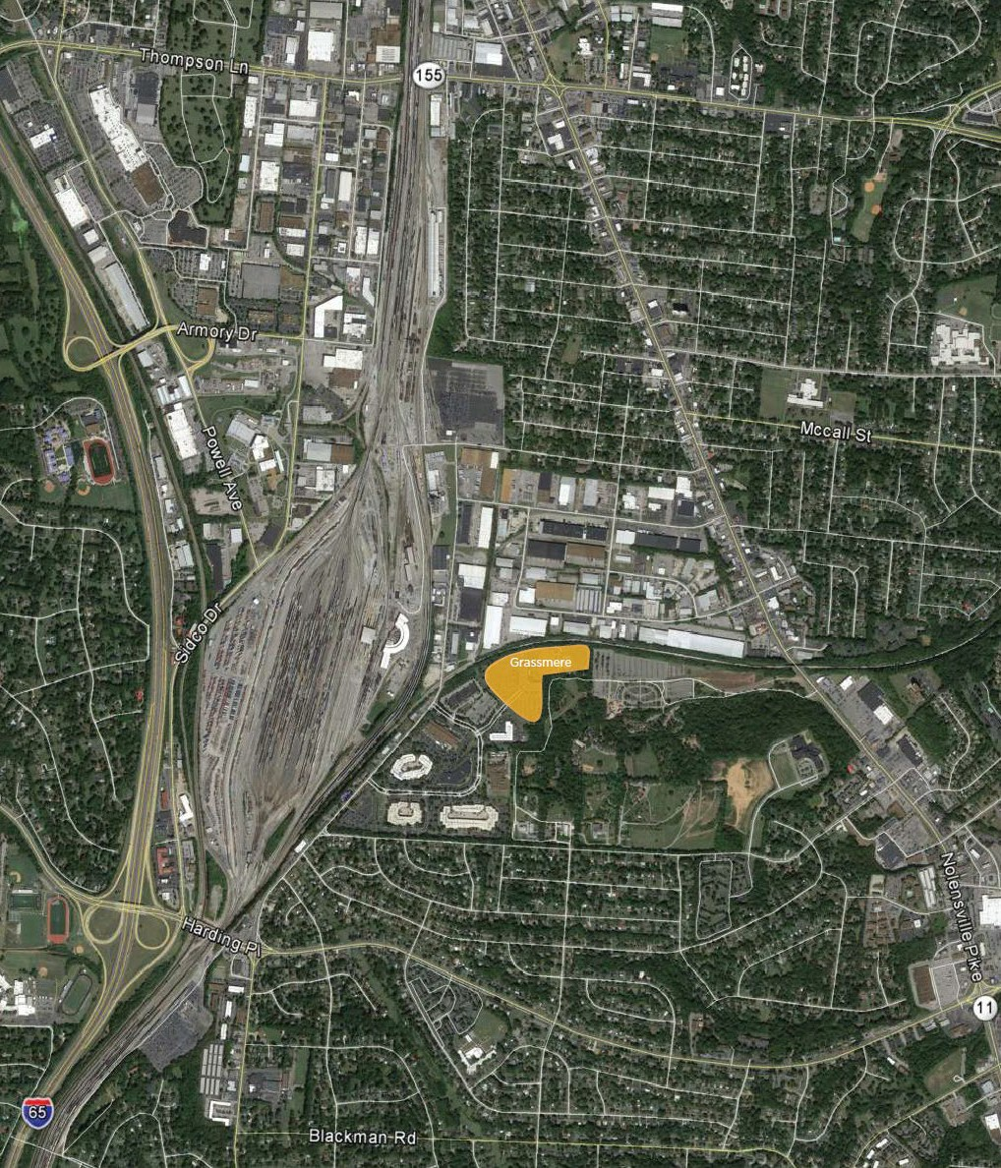

B: PROPERTY PHOTOS
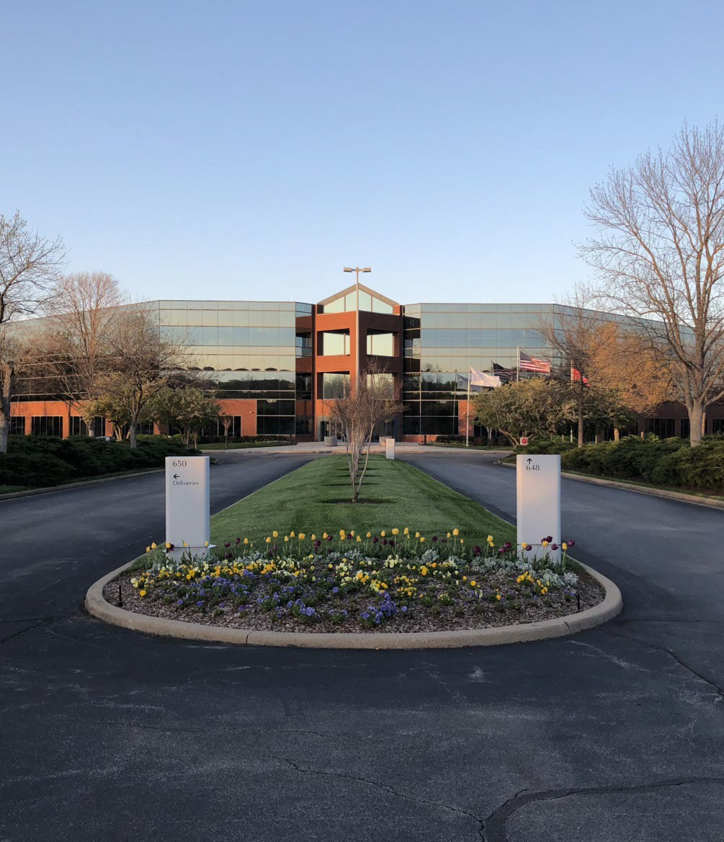

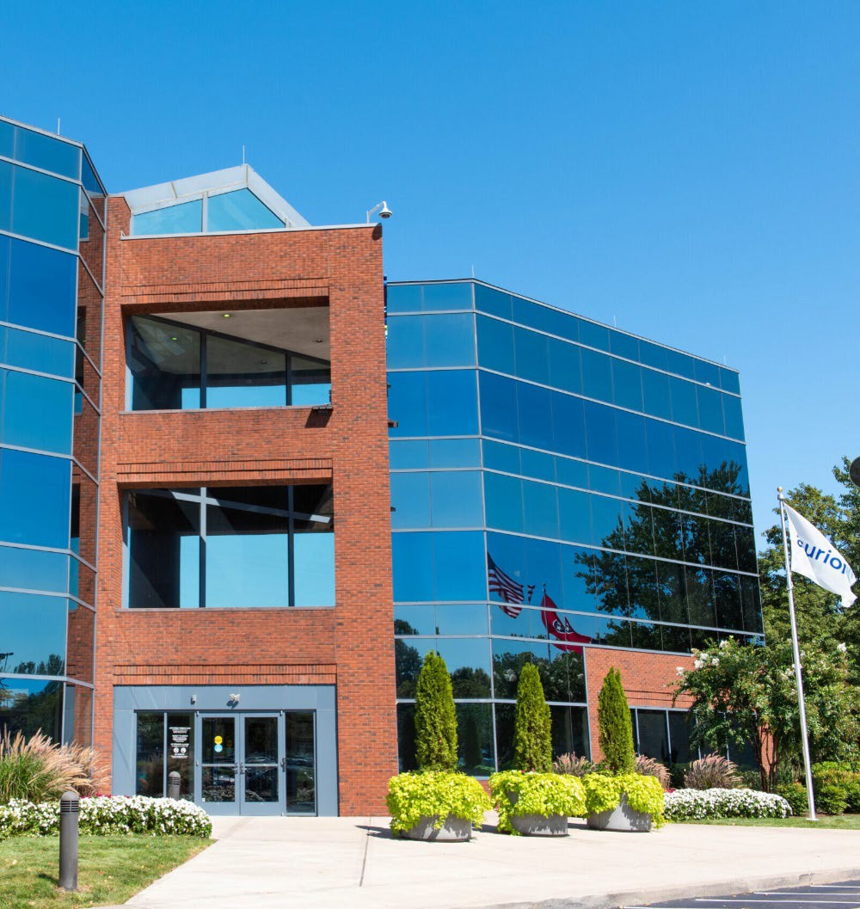

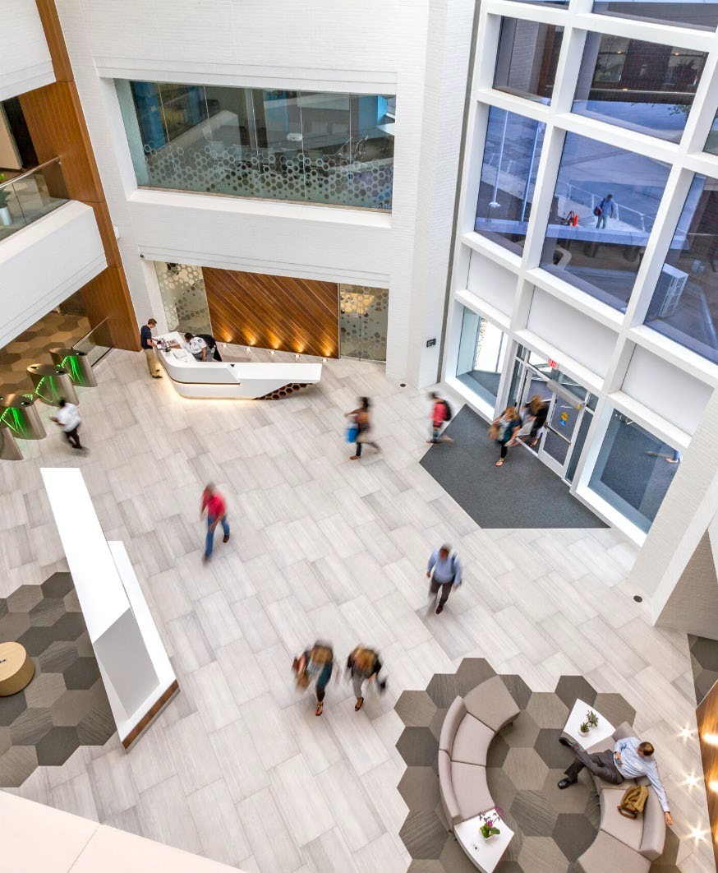

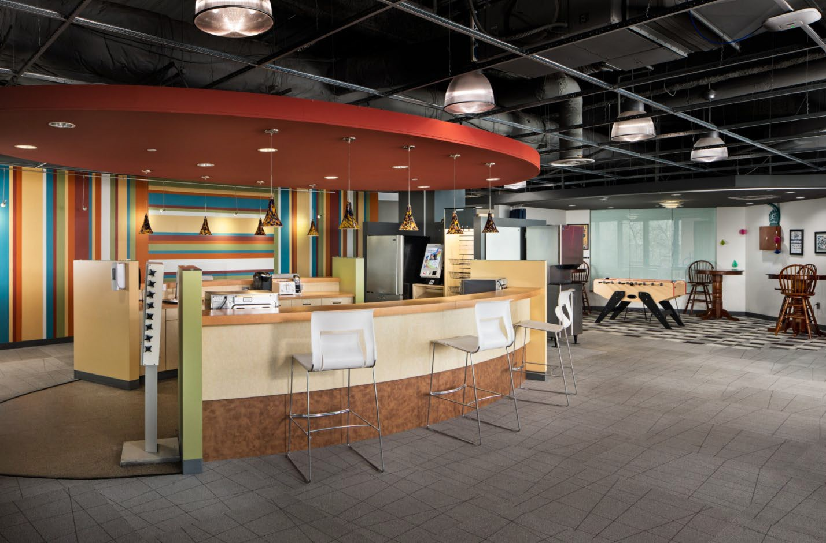

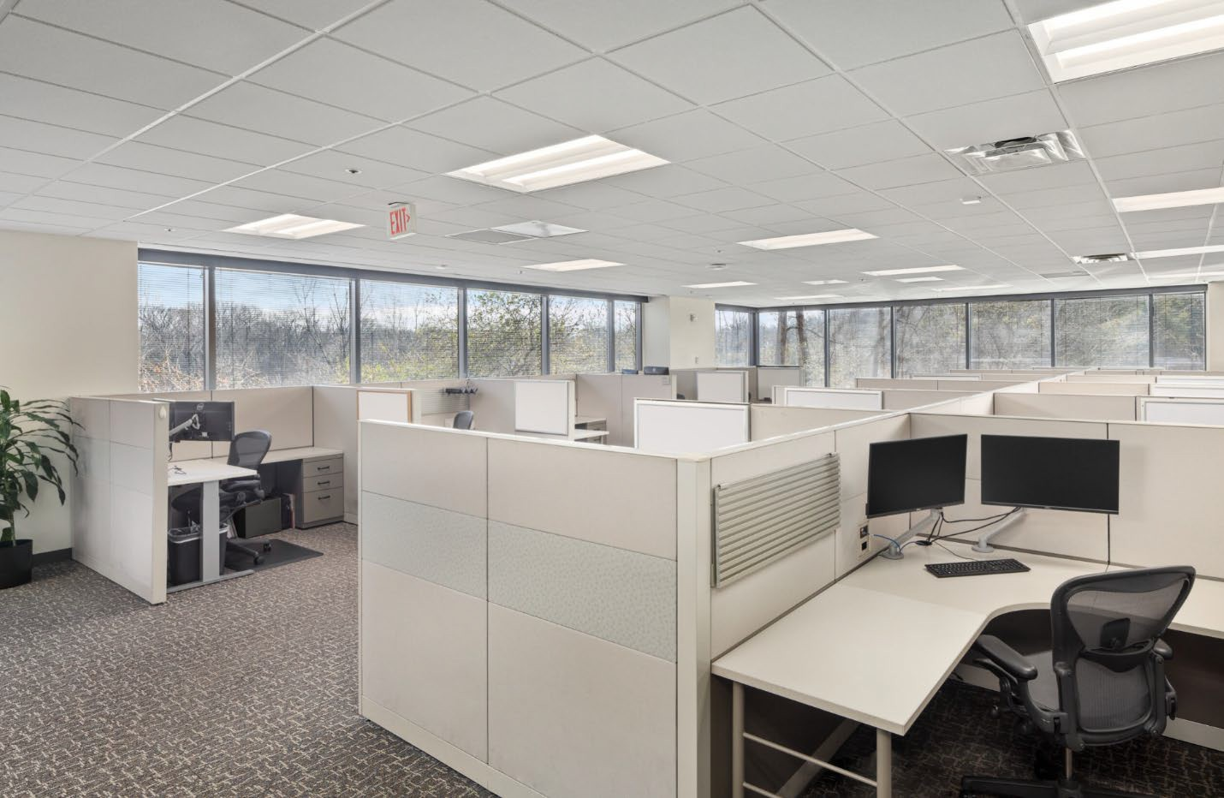

C: SITE SURVEY
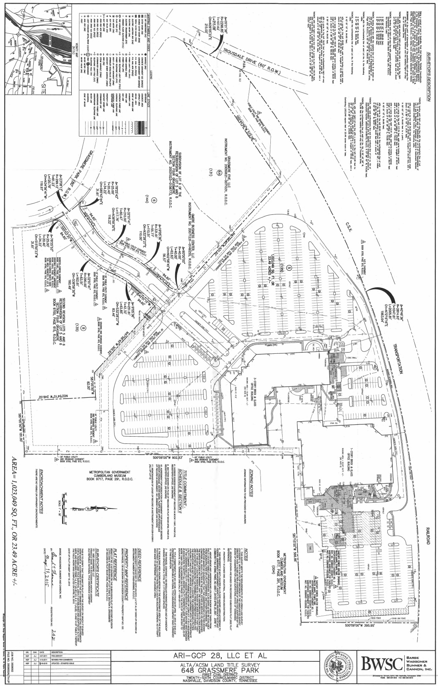

D: FLOOR PLANS
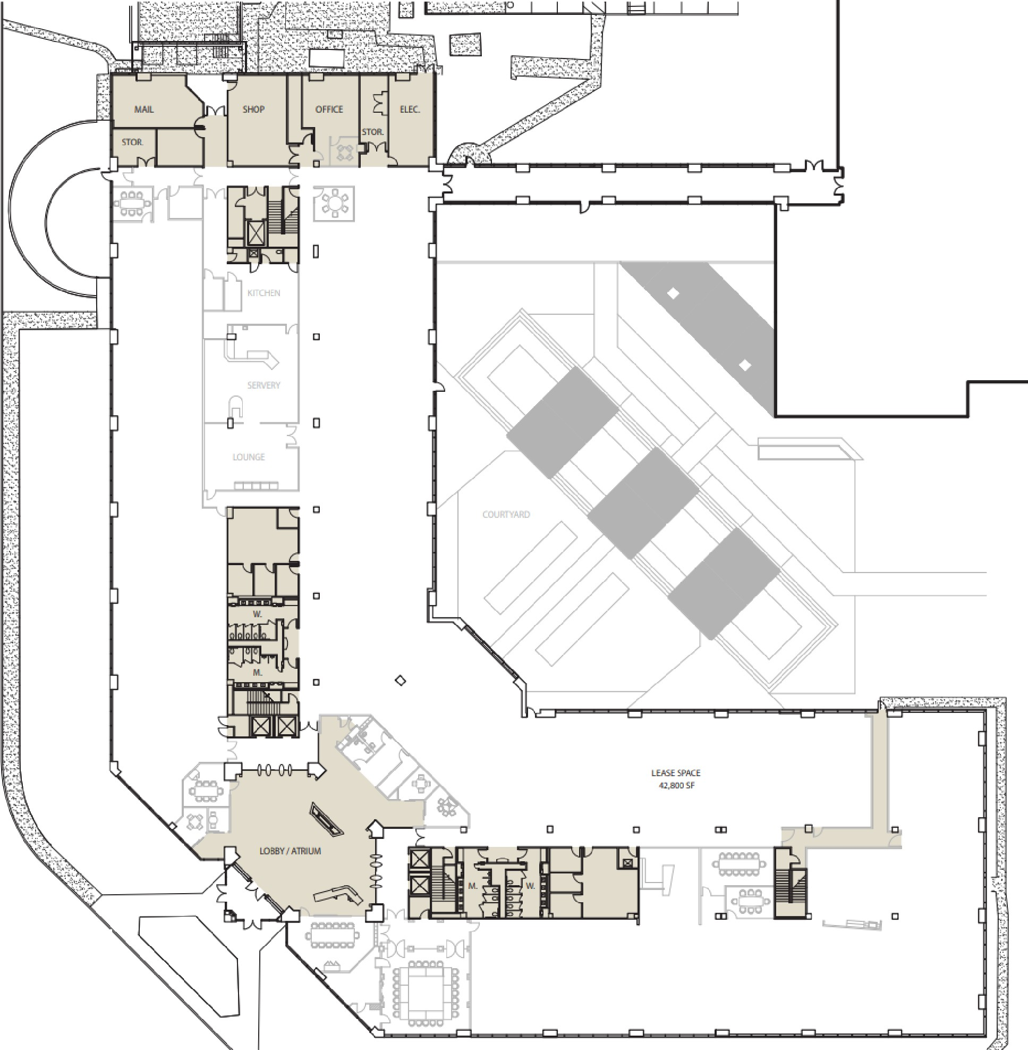
ANNEX
)
,-- ,.

SINGLE TENANT FIRST FLOOR 1"=40'-0' i. --.20'.

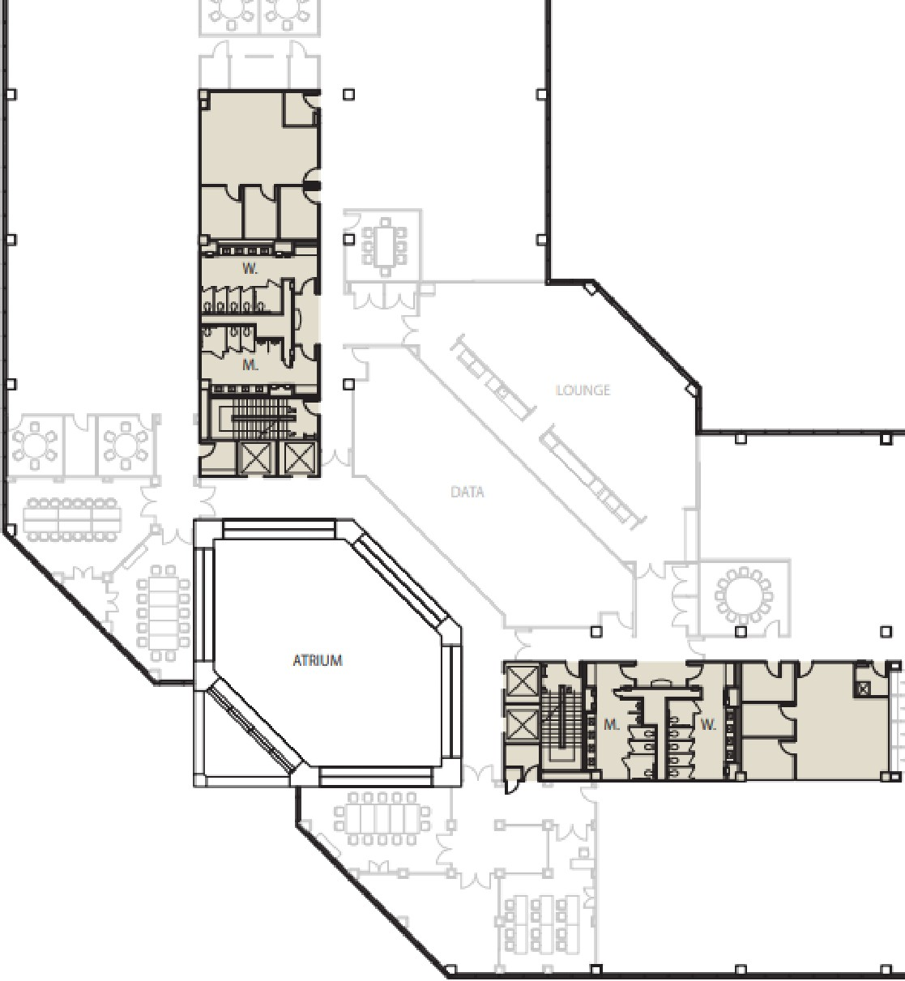
i:J
□
[li=ciJ
LEMESPAOE
41,60DSF
□
□


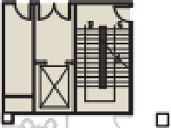

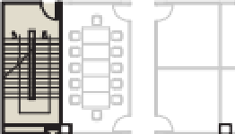
SINGLE TENANT SECOND FLOOR
,. = 40'-0" �
0 "'

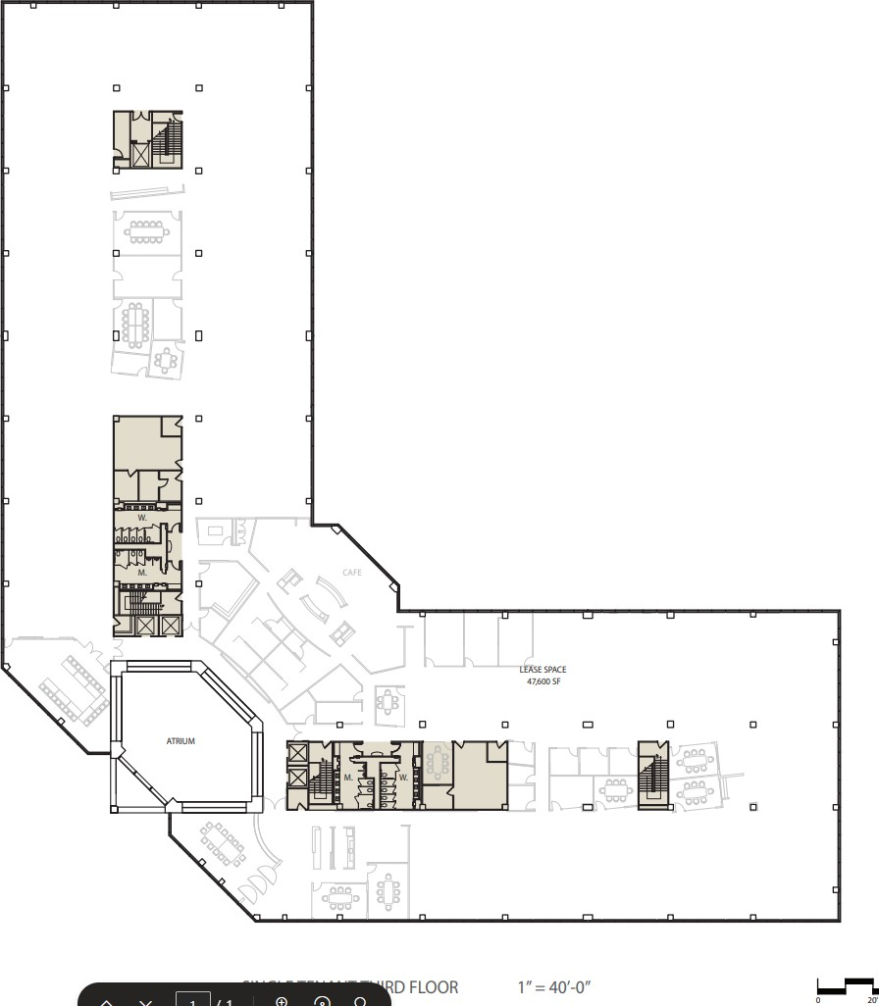

E: PROPERTY SUMMARY
Property Address 648 & 650 Grassmere Park Drive Nashville, TN 37211 Description Three-story office building and one-story annex Year Built 1985 (Most recent expansion in 2011)
Number of Buildings 2
Building Area 224,199 Square Feet 648 Grassmere 162,550 Square Feet
650 Grassmere 61,649 Square Feet Land Area ± 23.49 AC
Zoning IWD (Industrial Warehousing/Distribution) - Permitted uses include office Structure Three-story composite; One-story steel bar joist.
Exterior Walls Brick facade with aluminum glass curtain walls. Exterior Doors Aluminum glass; in porcelain enamel vestibule.
Elevators Five Dover elevators; four 3,000-lb passenger elevators and one 4,500-lb freight elevator in main building – all hydraulic.
Stairways Four stair wells serve the main building.
Loading Facilities Three docks; One in main building, Two in annex. 1 ramp, 6’ wide, angle incline. Secured after hours by camera, mechanically locked doors, and burglar monitoring."
Floors Lobby: 4”x8” Brick – Endicott dark ironspot. Building Standard: Raised 10” computer floor w/ carpet tiles; sealed 8”x8” floor tiles. Raised computer flooring throughout with under floor ducts.
Interior Walls Painted gypsum board with accent wall fabric, Three-story atrium with skylight.
Interior Doors Solid core with plastic laminate finish stainless steel lever hardware. Ceiling 2’x2’ acoustic drop-in ceiling tiles, 9’-0” ceiling height.
Interior Lighting Time controlled lighting. LED throughout. Power 650 Grassmere Generator Capacity – 1000 kW
648 Grassmere Generator Capacity – 1250 kW"
Back Up Generator 1250 kW diesel generator equipped with an above grade diesel storage tank.
Sprinklers Main building control office fully sprinklered, dry chemical extinguishment system; annex equipped with 13-lb Halon fire extinguishers, smoke dampers on back wing of all floors, life safety alarms transmitted via monitoring company.
Parking Total Parking includes 1205 asphalt spaces with a ratio of 5.4 per 1,000 sf HVAC Regulated with building automation system. Comfort control is provided
by variable air volume with VAV terminals for interior zones and powered
induction units with electrical resistance, heating is provided by electrical resistance and distributed by VAV boxes with re-heat coils. The building cooling plant is comprised of a fully redundant high-efficiency water cooled chiller plant, complete with distribution pumps, cooling towers and water treatment. The entire system is backed up by on-site generators.

F: OPERATING SUMMARY

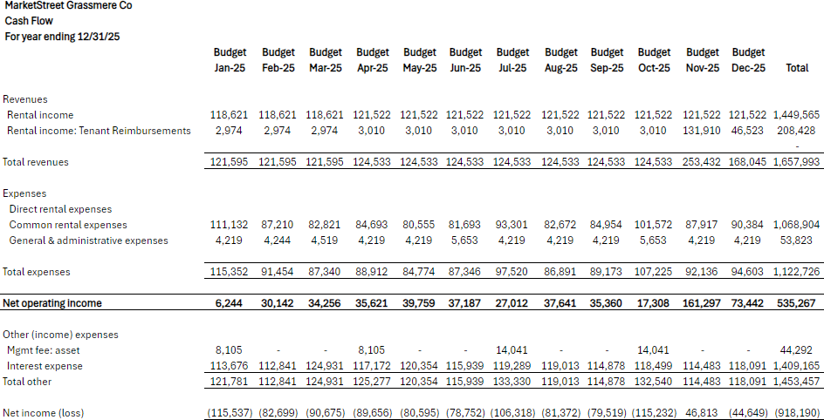

G. LOAN SUMMARY
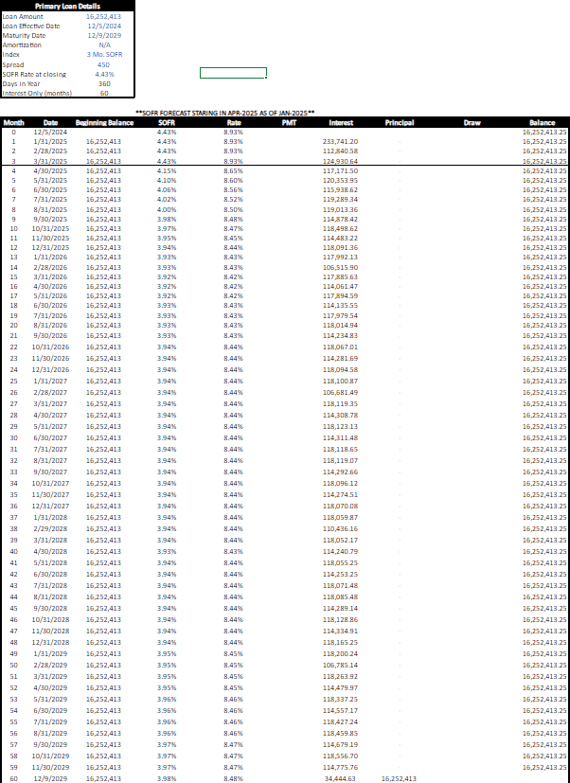

G. ZONING SUMMARY

Metro Government of Nashville and Davidson County, TN Title 17: Zoning Ordinance
Link: 17.08.020 - Zoning districts described. | Code of Ordinances | Metro Government of Nashville and Davidson County, TN | Municode Library

17.08.020 - Zoning districts described
Industrial Districts. The industrial districts will implement the various industrial policy objectives of the general plan. The range of permitted uses, bulk requirements and operational standards reflect the intended purpose of the respective district.
IWD, Industrial Warehousing/Distribution District. The IWD district implements those industrial policies of the general plan that provide opportunities for wholesaling, warehousing and bulk distribution uses. This district also may be used to implement major transportation policies of the general plan. By their nature, the principal uses of this district require relatively flat, large acreage tracts of land and may generate large volumes of heavy truck traffic, necessitating very good access to major arterial streets and the interstate system. Some businesses also may require direct rail or river access.

See Section 17.08.030 for the District Land Use Table that describes the permitted uses for IWD. See Section 17.16.090 for the Land Use Development Standards for industrial uses.

